CASE STUDY in SQL WORKBENCH:

CODE:

-- Create Database

CREATE DATABASE casestudy;

-- Use the Database

USE casestudy;

-- Create Train Table

CREATE TABLE Train (

Train_ID INT PRIMARY KEY,

Train_Name VARCHAR(100),

Departure_Station VARCHAR(100),

Arrival_Station VARCHAR(100),

Departure_Time TIME,

Arrival_Time TIME,

Total_Seats INT,

Available_Seats INT

);

-- Insert data into Train Table

INSERT INTO Train (Train_ID, Train_Name, Departure_Station, Arrival_Station, Departure_Time, Arrival_Time, Total_Seats, Available_Seats)

VALUES

(1, 'Express 101', 'Guntur', 'Chennai', '08:00:00', '10:40:00', 200, 180),

(2, 'Express 101', 'Guntur', 'Chennai', '08:00:00', '10:40:00', 200, 180),

(3, 'Express 101', 'Guntur', 'Chennai', '08:00:00', '10:40:00', 200, 180);

select * from Train;

-- Create Passenger Table

CREATE TABLE Passenger (

Passenger_ID INT PRIMARY KEY,

Name VARCHAR(100),

Contact_Number VARCHAR(20),

Address TEXT

);

-- Insert data into Passenger Table

INSERT INTO Passenger (Passenger_ID, Name, Contact_Number, Address)

VALUES

(1, 'Akhil', '8179421105', '123 Neerukonda, Guntur, AP'),

(2, 'Arun', '7654799332', '456 kuragallu, Guntur, AP'),

(3, 'Ameen', '8273645980', '789 nidamaru, Guntur, AP');

select * from Passenger;

-- Create Reservation Table

CREATE TABLE Reservation (

Reservation_ID INT PRIMARY KEY,

Passenger_ID INT,

Train_ID INT,

Seat_Number INT,

Date DATE,

FOREIGN KEY (Passenger_ID) REFERENCES Passenger(Passenger_ID),

FOREIGN KEY (Train_ID) REFERENCES Train(Train_ID)

);

-- Insert data into Reservation Table

INSERT INTO Reservation (Reservation_ID, Passenger_ID, Train_ID, Seat_Number, Date)

VALUES

(1, 1, 1, 5, '2023-10-27'),

(2, 2, 2, 6, '2023-10-27'),

(3, 3, 3, 7, '2023-10-27');

select * from Reservation;

-- Create Ticket Table

CREATE TABLE Ticket (

Ticket_ID INT PRIMARY KEY,

Reservation_ID INT,

Fare DECIMAL(10, 2),

Payment_Status VARCHAR(20),

FOREIGN KEY (Reservation_ID) REFERENCES Reservation(Reservation_ID)

);

-- Insert data into Ticket Table

INSERT INTO Ticket (Ticket_ID, Reservation_ID, Fare, Payment_Status)

VALUES

(1, 1, 100.00, 'Paid'),

(2, 2, 100.00, 'Paid'),

(3, 3, 100.00, 'Paid');

select* from Ticket;

-- Create Station Table

CREATE TABLE Station (

Station_ID INT PRIMARY KEY,

Station_Name VARCHAR(100),

Location VARCHAR(100)

);

-- Insert data into Station Table

INSERT INTO Station (Station_ID, Station_Name, Location)

VALUES

(1, 'Guntur', 'Mangalagiri, AP'),

(2, 'Guntur', 'Mangalagiri, AP'),

(3, 'Guntur', 'Mangalagiri, AP');

select * from Station;

-- Create Employee Table

CREATE TABLE Employee (

Employee_ID INT PRIMARY KEY,

Name VARCHAR(100),

Position VARCHAR(100),

Contact_Number VARCHAR(20)

);

-- Insert data into Employee Table

INSERT INTO Employee (Employee_ID, Name, Position, Contact_Number)

VALUES

(1, 'Abhinav', 'Conductor', '9875436210'),

(2, 'Lohith', 'Ticket Agent', '1234567899'),

(3, 'Venky', 'Engineer', '8764538290');

select * from Employee;

Output:

Table – 01:

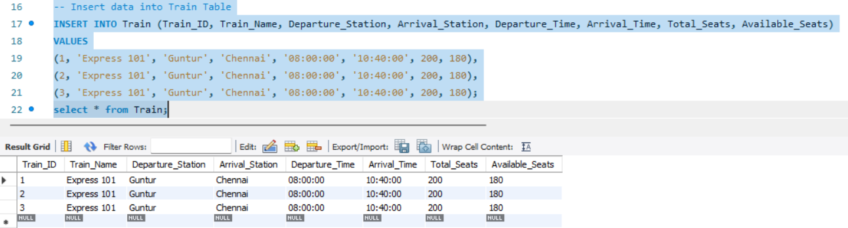

Table – 02:

Table – 03:

Table – 04:

Table – 05:

Table – 06:

E-R Diagram from SQL Benchmark:

